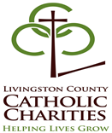
A LASTING PROMISE
Christian Communication and Relationship Enhancement Seminars Schedule 2019-2020
FACILITATOR | DATE | TIME | LOCATION
********* | ******** | ******** | *******
Deacon Jeff and Sandy  Southerland | Sat. - Nov. 09, 2019 | 9:30 AM to 4:30 PM | Livingston County Catholic Charities  2020 E. Grand River, Ste. 104  Howell, MI 48843
Tom and Cindy Rey | Mon. - Feb. 03, 2020  Wed.- Feb. 05, 2020 | 6:30 PM to 9:30 PM  6:30 PM to 9:30 PM | Livingston County Catholic Charities  2020 E. Grand River, Ste. 104  Howell, MI 48843
Deacon Jeff and Sandy  Southerland | Sat. – March 21, 2020 | 9:30 AM to 4:30 PM | Livingston County Catholic Charities  2020 E. Grand River, Ste. 104  Howell, MI 48843
Tom & Cindy Rey | Sat. – May 2, 2020 | 9:30 AM to 4:30 PM | Livingston County Catholic Charities  2020 E. Grand River, Ste. 104  Howell, MI 48843
Deacon Jeff & Sandy  Southerland | Mon. – June 01, 2020  Wed. – June 03, 2020 | 6:30 PM to 9:30 PM  6:30 PM to 9:30 PM | Livingston County Catholic Charities  2020 E. Grand River, Ste. 104  Howell, MI 48843
Tom & Cindy Rey | Sat. – Aug. 22, 2020 | 9:30 AM to 4:30 PM | Livingston County Catholic Charities  2020 E. Grand River, Ste. 104  Howell, MI 48843

A LASTING PROMISE REGISTRATION FORM
*** P L E A S E P R I N T ***
Registration Fee: $75.00
Date of Class_________________________

BRIDE______________________________ GROOM____________________________________

Address_____________________________ Address____________________________________

City/State____________________________ City/State___________________________________

Zip Code_____________________________ Zip Code___________________________________

Phone (Home)___________(Work)__________ Phone (Home)___________(Work)___________

Parish_________________________________ Parish_____________________________________

Occupation_____________________________ Occupation_________________________________

1st Marriage__________Remarriage________ 1st Marriage___________Remarriage_____________

Length of Relationship___________ years_________ Date of Wedding________________________

Mail letter of attendance to:
Officiating Priest or Deacon____________________________________________________________
Church Address______________________________________________________________________
Please attach check payable to: Livingston County Catholic Charities A LASTING PROMISE
2020 E. Grand River Ave., Suite 104, Howell, MI 48843 .
DEADLINE FOR REGISTRATION: Registration is recommended a minimum of 4 weeks
prior to the date of the class you plan to attend. Class size is limited. Notify LCCC as soon as possible when canceling (517) 545-5944.

A LASTING PROMISE
CHRISTIAN RELATIONSHIP
ENHANCEMENT SEMINAR

Based on the highly acclaimed program: Prevention and Relationship Enhancement Program (PREP). This program is designed to teach couples communication skills and techniques for handling conflict and promoting intimacy with the aim of preventing future marital problems and divorce.

This program emphasizes constructive arguing techniques that allow couples to adjust their communication styles and achieve more positive and intimate communication, in a Christian setting.

Other key topics include:
Expectations, commitment, values, and beliefs

U:/Jaynee/promisenew19-20.doc

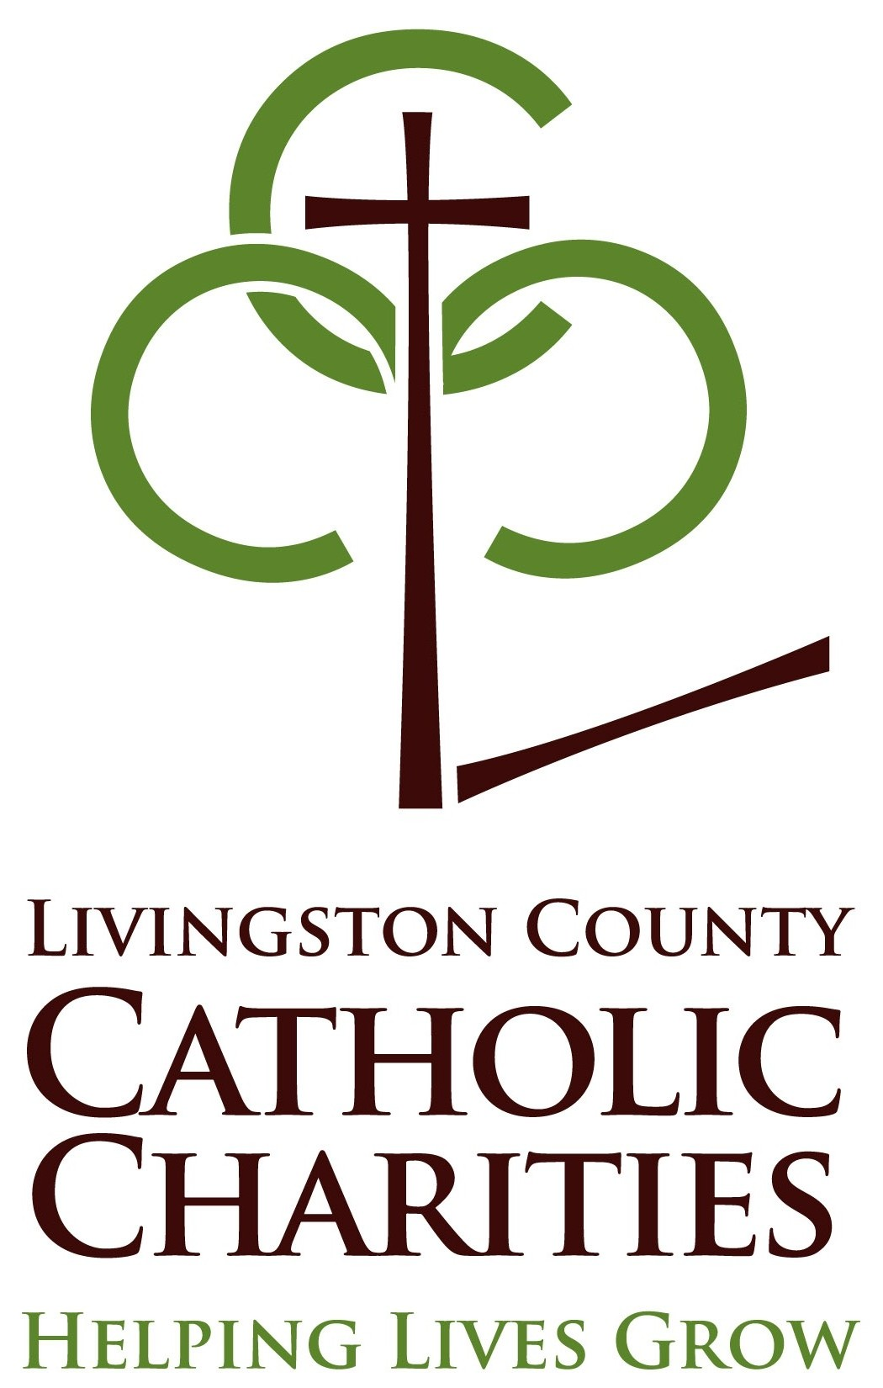

A Lasting Promise Program teaches:
- How to communicate what you want out of your relationships.
- How to resolve conflict effectively and reduce arguments.
- How to solve problems as a team.
- How to keep friendship and intimacy a part of your relationship.
- How to develop skills to enhance understanding and maintain commitment.

Diocese of Lansing
Marriage Preparation Classes
Nov. 2019 to Aug. 2020
A LASTING PROMISE
CHRISTIAN RELATIONSHIP
ENHANCEMENT SEMINAR

Sponsored by
Diocese of Lansing
Family Ministry
And
Livingston County Catholic Charities
2020 E. Grand River, #104
Howell, MI 48843
(517) 545-5944

