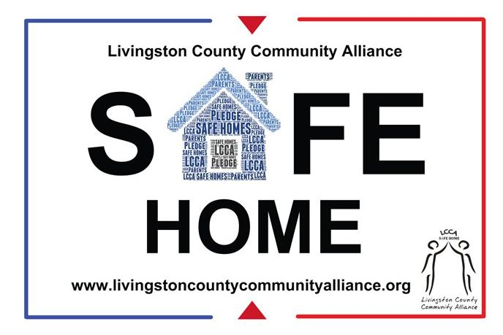
Safe Homes Program Brief FY 2017-2018

Logistics:
The Livingston COMMUNITY PREVENTION Project (LCPP) was formed in 2008 to provide substance abuse prevention services throughout Livingston County. Karen Bergbower & Associates, Key Development Center, Inc., LACASA, and Livingston County Catholic Charities are the collaborative partners of LCPP. These agencies work together to implement several prevention programs that have been proven to impact substance use and related problems. LCPP provides an array of prevention services that target all sectors of Livingston County, including parents, schools, and the community. LCPP is focusing on the following CMHPSM priority areas: reducing childhood and underage drinking, reducing prescription and over the counter drug abuse/misuse, and reducing illicit drug use.
LCPP has targeted Livingston County as a whole with special emphasis in the community of Pinckney. The Livingston County Community Alliance (LCCA) and It Stops with Students (ISWS) work closely with all five school districts as well as local government, law enforcement, and community members.

Priority Area, Primary Problems, and Associated Intervening Variables:
CMHPSM Priority Area 1: Reducing Childhood and Underage Drinking
- Primary Problem: Early Addiction, Delinquent/Problem Behavior
- Intervening Variables: Lack of Perceived Risk, Peer Pressure, Prosocial Attitudes toward School, Norms that Support Use, Easy Access to Alcohol, Parental Norms, Attitudes, and Knowledge of Underage Drinking
CMHPSM Priority Area 2: Reduce Prescription and Over-the-Counter Drug Abuse/Misuse
- Primary Problem: Early Addiction, Delinquent/Problem Behavior
- Intervening Variables: Easy Access to Prescription Drugs, Parental Norms and Attitudes, Community Norms and Attitudes
CMHPSM Priority Area 4: Reduce Illicit Drug Use
- Primary Problem: Early Addiction, Delinquent/Problem Behavior
- Intervening Variables: Parental Norms and Attitudes, Community Norms and Attitudes

EBI and CSAP Prevention Strategies:
Originally developed by the Pennsylvania Liquor Control Commission, Safe Homes is an online based parent networking campaign in which adults make a pledge to keep their home drug and alcohol free. By becoming a Safe Home, parents and other adults take a pledge that they will actively supervise all gatherings or parties of youth, prohibit the possession or use of alcohol, prescription drugs taken for recreational purposes and illicit drugs by youth in their home, set expectations for their children regarding drugs, provide a secure storage place for alcohol and prescription drugs, and talk to a parent of a child they personally observe using drugs and alcohol. Safe Homes also raises awareness of the fact that 72% of Livingston County teens who drink alcohol, consume it at a friend’s home. The campaign encourages parents and other adults to send a unified message that drug and teen alcohol consumption will not be tolerated while emphasizing the importance of speaking with kids about drug and alcohol use. This pledge can be found online as well as a hard copy.
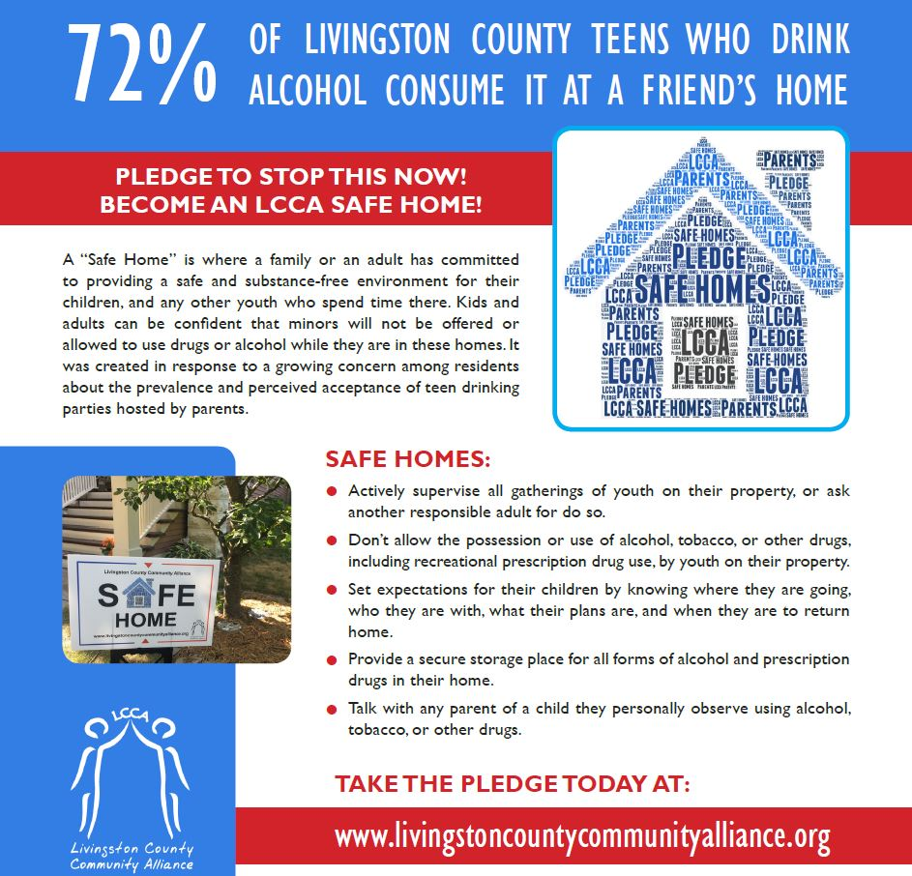
Safe Homes is implemented locally by Project SUCCESS Counselors, CBSG Counselors, and the Livingston County Community Alliance – using the following Center for Substance Abuse Prevention (CSAP) intervention strategies: information dissemination, education, community based process, and environmental. This campaign debuted this year due to its success in surrounding counties.
Because the campaign tool-kit only came with the pledge, the LCPP and LCCA had to design the look of the campaign, including the logo, publicity materials, and website design. The LCPP utilized LCCA’s underage drinking committee and marketing committee to create the logo and materials. County statistics were also included in the material to educate parents about the prevalence of youth substance use taking place in their home. Yard signs, window clings, and posters were then printed and distributed to people who took the pledge. Parents who receive the yard signs and window clings frequently comment that it feels like “a badge of honor” to be able to post their yard sign.
The campaign continues to utilize the community based process. Through the use of the SPF, community members were asked what was important to them when organizing a parent-targeted campaign. They mentioned an online based campaign where parents could speak with other parents. Because Safe Homes has been effective in other areas, the LCPP decided to implement it in Livingston County.
Safe Homes is a valuable tool for communities to address environmental factors which contribute to underage drinking and drug use. These environmental factors directly relate to the CMHPSM’s priority areas and LCPP’s primary problems and intervening variables.
- Safe Homes strives to create consistent parental and community norms that underage drinking and drug use is not only illegal, but is unsafe, unhealthy and unacceptable.
- By increasing parental awareness and understanding of the health, safety and legal consequences of allowing drug use and underage drinking, Safe Homes reduces the number of parents who allow underage drinking and drug use on their premises and property, which decreases underage access to alcohol and drugs.
- Safe Homes provides clear, consistent messages that are easily communicated by every sector of the community, including parents.
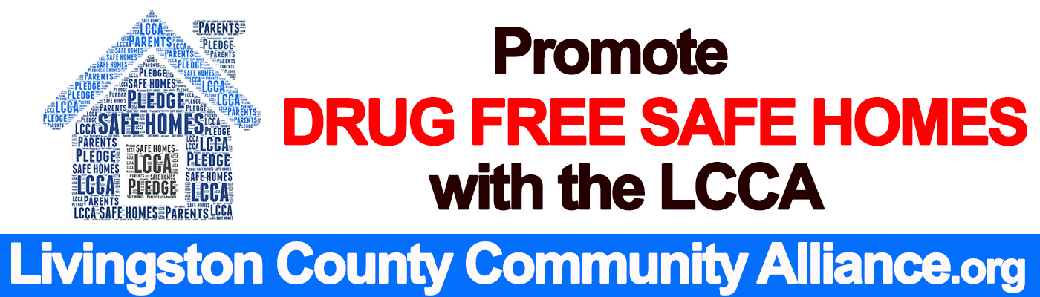
- Safe Homes improves enforcement consistency by offering suggestions to help communities improve local enforcement of this and other underage drinking laws. The program also provides many opportunities for law enforcement to partner with other community leaders to communicate clear community standards related to underage drinking.

Outcomes/Results:
Throughout the course of FY 17/18, Safe Homes has shown impact on reducing childhood and underage drinking (CMHPSM Priority Area 1) in Livingston County as shown by the year-end survey:
- 66% of participants said that the Safe Homes information was helpful to them and their family
- 66% of participants responded that if parents knew this information, it would keep them from hosting teen gatherings or parties where teens are allowed to use alcohol and drugs.
- 67% of participants reported that the information led to a discussion between them and their teen(s) about the importance of adult supervision at teen gatherings or parties.
- 64% of participants reported that the information led to a discussion with other parents about the importance of actively supervising all teen gatherings or parties hosted at their home or on their property.
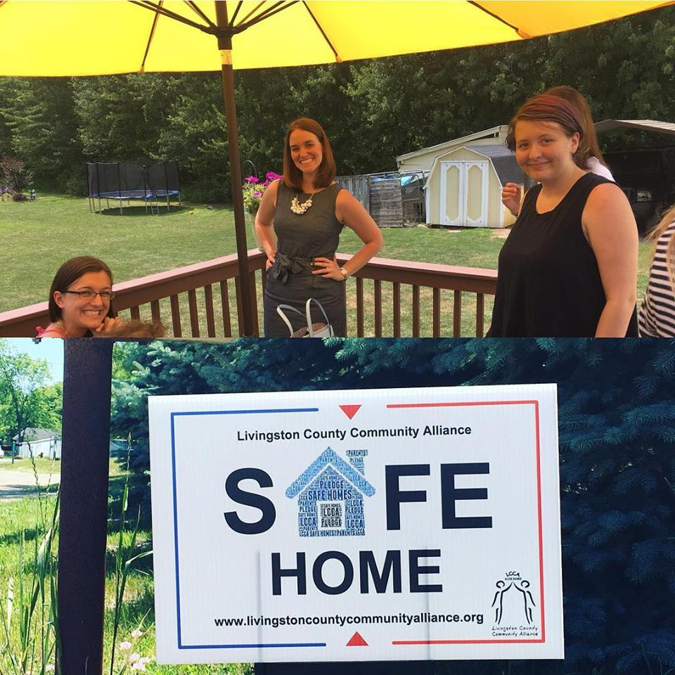
- 83% of participants reported that they are comfortable contacting other parents to verify there will be supervision at teen gatherings or parties hosted at their home or on their property.

In addition, this campaign caught the attention of WDIV-Channel 4 News. Channel 4 taped a video segment about the campaign, interviewing the Substance Abuse Prevention Director, the Fowlerville Police Chief, local community members, and teens from Fowlerville Public Schools. The segment is set to air in October.

